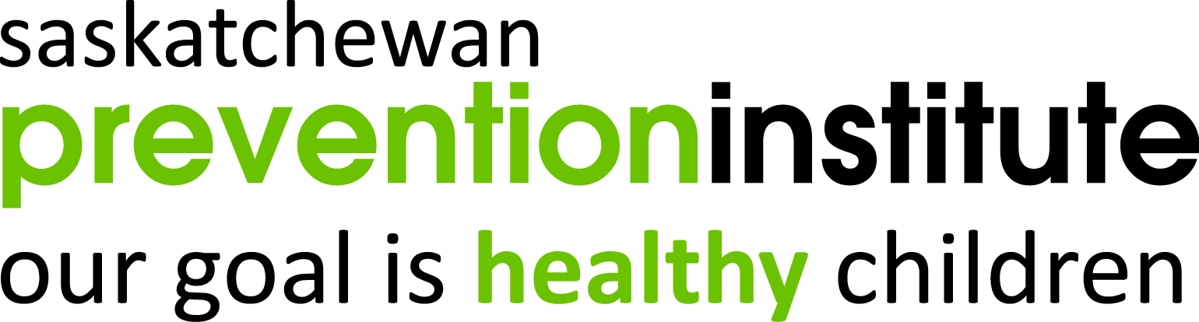
Prevention Matters 2019
Connecting and Collaborating
Learning from One Another for Healthy
Child Development and Well-Being
October 2-4, 2019, TCU Place, Saskatoon, SK

REGISTRATION FEES

* REGISTRATION DEADLINE: SEPTEMBER 18, 2019 *
☐ One Day Medical Stream (Ends Sept. 18, 2019) $225.00
☐ Special Early Bird Registration (Ends March 31, 2019) $350.00
☐ Early Bird Registration (April 1 – June 30, 2019) $400.00
☐ Regular Registration (July 1 – Sept. 24, 2019) $425.00

- Student pricing is available. Please call for more information.
- Your receipt will be emailed to you, which is your confirmation of registration.
- Certificates of attendance will be issued upon request.
- Refunds: Written cancellations received by August 31, 2019 will be refunded, less a $75.00 administration fee. No refund will be given for cancellation requests received on or after September 1, 2019. No exceptions to this policy will be made. Refunds will be issued after October 31, 2019.

REGISTRANT INFORMATION

Last Name First Name

Organization/Company

Role/Position (e.g., Support Worker, Family Physician, Dietician)

Address

City Prov/State Postal Code/Zip

Email Address

Phone Fax

Function at Conference (check one):
Delegate Presenter CAPC Participant

MEDICAL STREAM
The medical stream fits within the general conference, building on the overall purpose of the conference to meet the professional development needs of healthcare providers in Saskatchewan.

Conference delegates who attend the 3-day conference may choose to attend the medical stream on the second day.

Will you be attending the medical stream? ☐ Yes ☐ No

PAYMENT
Payment can be made by cheque, Visa, or MasterCard.

Please check the method of payment:
Visa MasterCard Cheque Other

Visa or MasterCard Number
/
Expiry Date (mm/yyyy) Cardholder’s Name

Send form and full payment by email, fax, or mail to:
Saskatchewan Prevention Institute
1319 Colony Street, Saskatoon, SK S7N 2Z1
Phone: 306-651-4300 Fax: 306-651-4301
Email: info@skprevention.ca

Cheque payable to Saskatchewan Prevention Institute

DIETARY NEEDS

If you have any serious food allergies or dietary restrictions, please contact us at 306-651-4300 or by email to info@skprevention.ca.

For questions regarding registration,
please email info@skprevention.ca
or call 306-651-4300.

