Nobody’s Perfect Parenting Program
Resource Order Form & Grant Application
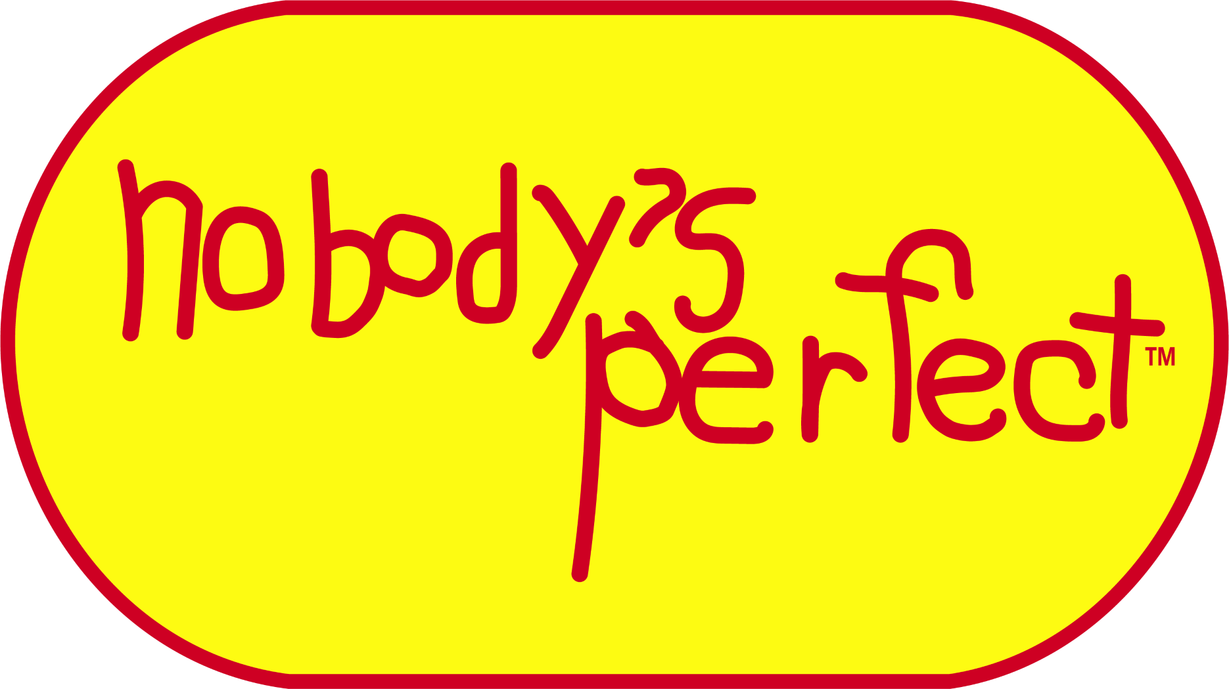
NOTE: To be filled out and sent in 1 month prior to Nobody’s Perfect Parent Program.

A. PARENT PROGRAM NOTICE:

Sponsoring Organization: _____________________________ Program Dates: ____________________

Facilitator: _________________________ Co-Facilitator: _____________________________________

Phone: __________________ Email: ______________________________

Address: _______________________ City/Community: _________________ Postal Code: __________

B. Do you require a Nobody’s Perfect Grant consisting of 8 Nobody’s Perfect Parent Kit Books?
Yes No

*Please Note: Organizations qualify for 1 Nobody’s Perfect Grant (set of 8 NP Parent Kits, plus shipping of these kits) per fiscal year. If you need additional resources, please refer to section C below.

C. PROGRAM MATERIAL ORDER FORM: Resource materials not required.

Order Date: _________________________ Date Required: ____________________

Quantity | Unit Cost | Item | Cost
 | $27.00 | Parent Kit (Safety, Body, Mind, Behaviour & Parent Books)
 | No Charge | Nobody’s Perfect National Brochures
 | No Charge | “Cherish Me for I am a Child” Poster
 | $5.00 | Dads Make a Difference Playing Cards (for facilitators only)
 | $5.00 | Dads Make a Difference Manual (for facilitators only)
 | $5.00 | Parenting Matters Playing Cards (for facilitators only)
 | $5.00 | Parenting Matters User and Reflection Manual (for facilitators only)
 |  | Total Cost of Resources
SHIPPING | To be determined. | Shipping costs will be calculated and billed prior to shipment. There will be no cost if resources are picked up at the Saskatchewan Prevention Institute.
TOTAL

Ship to: Above Address Other _____________________________________________________

Method of Payment:
Payment sent with order form. Cheques are to be made payable to the Saskatchewan Prevention Institute.
Payment phoned in using credit card. Call 306-651-4300 to provide payment.
Please invoice to following agency and address: ___________________________________________

________________________ _______________________ ________________________
Signature of Recipient Print Name Date

Email, mail, or fax completed form to:
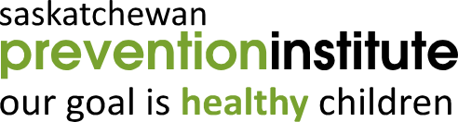
Nobody’s Perfect Parent Program
Saskatchewan Prevention Institute
1319 Colony Street, Saskatoon, SK S7N 2Z1
Phone: 306-651-4300 Fax: 306-651-4301
Email: info@skprevention.ca

Office Use Only: ______ Resources Processed and Sent ______ Grant Processed

